Desk Stand Up Reminder

Navarro, Rod Geryk C.

School of Electrical, Electronics, and Computer Engineering

Mapua University  
 Manila, Philippines

rgcnavarro@mymail.mapua.edu.ph

Abstract— The Desk Stand Up Reminder is an embedded system designed to help users maintain a healthier work routine by encouraging them to stand and move at set intervals. Utilizing an Arduino Uno R3 microcontroller, this project integrates components such as a 4-bit seven-segment display, an LCD I2C 1602, LEDs, a buzzer, and an ultrasonic sensor. The reminder functions by displaying countdowns and alerts, prompting the user to stand after prolonged sitting. The system is activated and reset through hand gestures over the ultrasonic sensor, providing a hands-free user experience. This project aims to apply embedded system skills and promote user wellness by supporting the 20-8-2 rule, which suggests sitting for 20 minutes, standing for 8 minutes, and moving for 2 minutes within every half hour.

Index Terms— Stand up reminder, Arduino UNO, Ultrasonic Sensor, LCD Module, 4-bit seven segment display

1. Introduction

In Prolonged periods of sitting have been linked to various health issues, making it important to incorporate regular movement into daily routines. The Desk Stand Up Reminder project addresses this need by using an embedded system to encourage users to stand and move at regular intervals. This project is designed using an Arduino Uno microcontroller and integrates key components such as a 4-bit seven-segment display, an LCD I2C 1602, LEDs, a buzzer, and an ultrasonic sensor. These elements work together to provide visual and auditory cues, reminding users when it is time to stand up. The project follows the 20-8-2 rule, which promotes a balanced work habit of sitting for 20 minutes, standing for 8 minutes, and moving for 2 minutes within every 30-minute cycle [1]. Users can adjust the sitting and standing times based on their preferences. The ultrasonic sensor allows for a hands-free way to activate or reset the system by simply hovering a hand over it. A study with the use of Arduino Uno to detect theft shows the effectiveness of using Arduino Uno in alarming users [2]. This document provides a detailed overview of the objectives, components, and implementation of the Desk Stand Up Reminder project, demonstrating the practical application of embedded system skills while promoting a healthier, more active lifestyle.

1. METHODOLOGY
2. Hardware Development

The hardware development of the Desk Stand Up Reminder project involves integrating an Arduino Uno microcontroller with essential components to ensure functionality and user interaction. The main elements include a 4-bit seven-segment display for showing the countdown timer and an LCD I2C 1602 to display task reminders and status updates. LEDs serve as visual indicators, signalling the user when it is time to prepare for standing, while a buzzer acts as an auditory alert for prolonged sitting. The project also incorporates buttons for user input to set the preferred sitting and standing times and an ultrasonic sensor that allows the user to reset or activate the system through a simple hand gesture. These components work together to create a reliable reminder tool that supports a balanced sitting and standing schedule, promoting a healthier lifestyle.

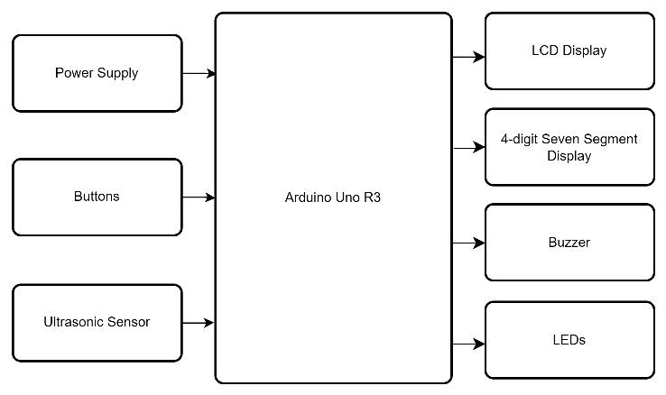

Fig. 1. Block Diagram for the Desk Stand up Reminder System.

1. Software Development

Fig. 2 represents the proposed system’s flowchart. C++ program, which powers the majority of Arduino boards, is utilized in the proposed project. As the primary coding tool for adding code to the system, the Arduino IDE is utilized. As of the program, the system flowchart is used as a basis for the needed code for this project. There are two timers in the system, the standing timer which is use for the time to stand up, and the sitting timer which is use for the time for work while sitting down. The device can allow the user to set their preferred time for the standing and sitting timers with a max of 30 mins in each timer. Each of the timers can be incremented and decremented by the user, also users could switch between timer settings. The seven-segment display will show the countdown timer of the current timer display, while the LCD will show various messages that can encourage the user to stand or to focus on their work based on the timer displayed, as well as the current timer running. After the current timer finishes it will enable the buzzer, LEDs, and ultrasonic sensor to notify the user to stand up or go back to work. To disable the buzzer as well as the LEDS, and ultrasonic sensor’s detection, the ultrasonic sensor must detect an object on top of it in the range of 10cm to disable the alarms and proceed to the next timer whether it is the standing or the sitting timer set by the user.

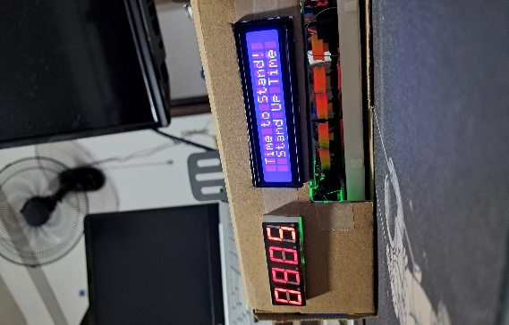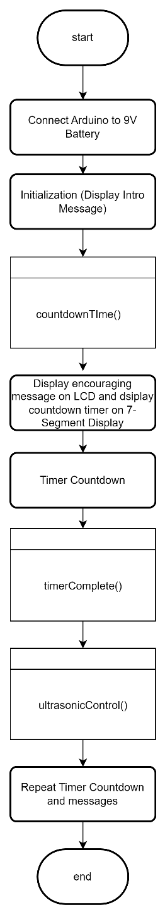

Fig. 2. Flowchart of the System.

1. Testing

The testing of the Desk Stand Up Reminder system involves several key steps to ensure its functionality and reliability. Initially, the device is powered by connecting it to a 9V battery, which activates the system and displays an introductory message on the LCD. The user can then set the sitting and standing timers by pressing button 5 to switch between the two. During this setup, the LCD will indicate which timer is being adjusted. The user can increment or decrement the sitting timer using button 1 and button 2, respectively, while buttons 3 and 4 serve the same purpose for the standing timer. Once the timers are set, the countdowns will be displayed on the 4-bit seven-segment display. Upon completion of the sitting timer, the system activates the buzzer and blinks the red and green LEDs, while the ultrasonic sensor detects objects within a 10 cm range. If no object is detected, the alerts continue; if an object is present, the alerts cease and the system transitions to the standing timer. The process is mirrored for the standing timer, with the buzzer and LEDs signalling the end of the countdown. Throughout this cycle, the LCD displays motivational messages to encourage the user to remain active. This systematic testing verifies that all components work together effectively, ensuring that the device fulfils its purpose of promoting a healthier work routine.

Fig. 3 The working prototype of the project is shown, including the complete casing and internal circuit. It also displays the outputs on the 4-bit seven-segment display and the LCD.

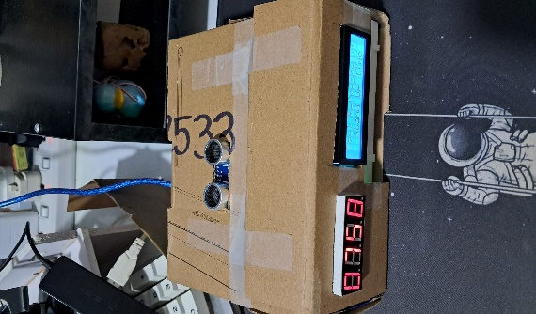

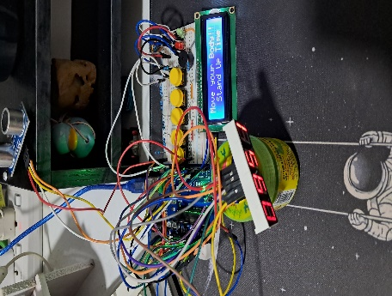

Fig. 3. Working Prototype of the Project and the circuit.

For Fig. 4-6, initialized variables and set up two primary timers—one for sitting and one for standing—with adjustable intervals shown on a 4-digit seven-segment display. Assigned five buttons to specific functions, ensuring accurate responses, and completed all functions to achieve project requirements.

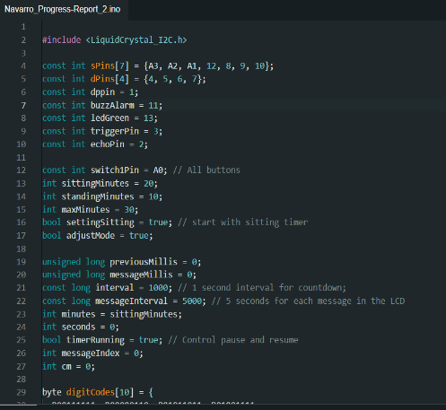

Fig. 4. Initialized variables as well as set up the two primary timers: one for sitting and another for standing, with adjustable intervals displayed on a 4-digit seven-segment display.

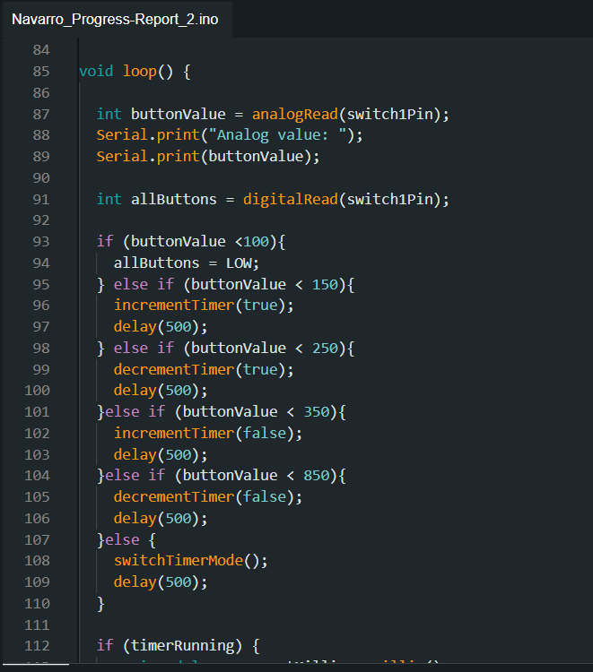

Fig. 5. Assigning the five buttons to their respective tasks ensuring that each button triggered with the intended response.

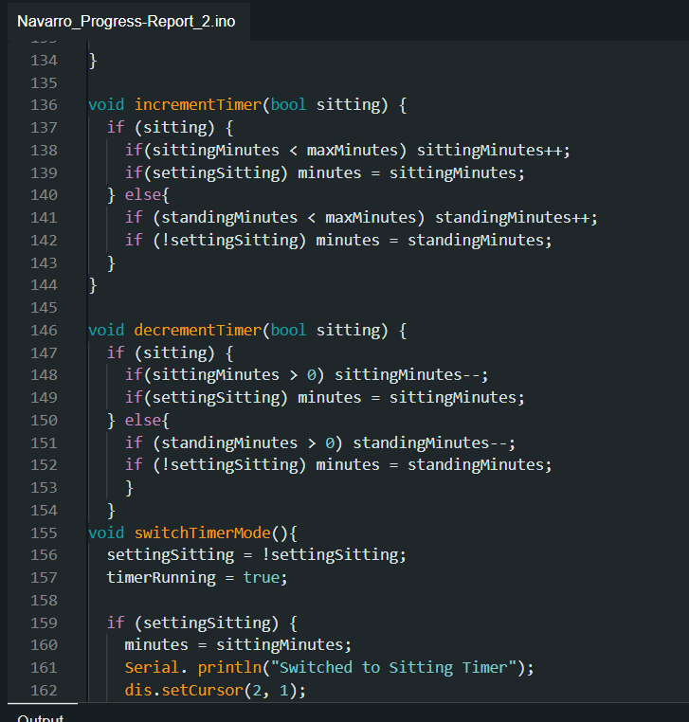

Fig. 6. Completing all the functions needed to achieve all the required outputs of the project.

1. Result and discussion

The Desk Stand Up Reminder project successfully met its objectives by demonstrating the practical use of an Arduino Uno microcontroller to create a reminder system that alerts users to stand after sitting for a long period. The integration of a 4-bit seven-segment display and an LCD I2C 1602 provided clear time indications and instructional messages, effectively guiding the user through the sitting and standing intervals. The LEDs served as visual cues, and the buzzer provided an audible alert, ensuring that the user was reminded promptly. The ultrasonic sensor allowed for intuitive user interaction by enabling hands-free activation and deactivation of the alarm. This project emphasized the importance of applying embedded system principles to develop a functional and health-conscious device. The results demonstrate how simple technologies can encourage users to maintain an active lifestyle, which aligns with health recommendations like the 20-8-2 rule. The project also showcased the effective application of embedded system skills learned during the course, supporting the development of practical solutions that promote well-being.

1. Conclusion and recommendations

The Desk Stand Up Reminder project successfully demonstrated the application of an embedded system to encourage healthier work habits by reminding users to stand up after prolonged sitting. Using an Arduino Uno, LCD, 4-bit seven-segment display, LEDs, a buzzer, and an ultrasonic sensor, the project effectively met its objectives and provided a practical solution for maintaining active routines. For future improvements, it is recommended to explore additional features such as adjustable alarms, user data tracking for standing habits, and integration with other health-monitoring tools to enhance user experience and motivation.

1. Explore additional features such as adjustable alarms.
2. User data tracking for standing habits
3. Integration with other health-monitoring tools to enhance user experience and motivation.

References

|  |  |
| --- | --- |
| [1] | C. Storrs, “CNN Health - Stand up, sit less and move more, researchers say; here’s how to do it,” 2015. [Online]. [Accessed november 2024].  https://edition.cnn.com/2015/08/06/health/how-to-move-more/index.html |
| [2] | D. M. B. Y. F. H. G. J. J. D. K. M. A. M. Z. P. J. N. B. J. A. G. -l. Michelle Joy Villanueva, “Theft alarm system using Arduino Uno’s PIR motion and tilt ball switch sensors,” *International Journal of Research Studies in Management,* 2023. 10.5861/ijrsm.2023.1023. |